AYUB BRIDGE

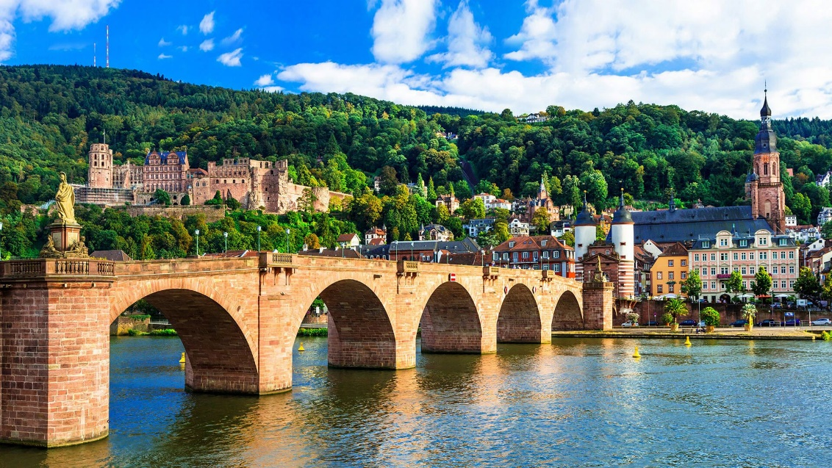

Ayub Bridge, a distinguished engineering marvel, spans gracefully across the Indus River, linking the cities of Sukkur and Rohri in Pakistan. Named after President Ayub Khan, it stands as a testament to his vision for modernization and progress in the country. This iconic structure, with its imposing pillars and intricate design, not only facilitates smooth vehicular movement but also serves as a symbol of connectivity and unity. Over the years, Ayub Bridge has become an integral part of the region's landscape, witnessing the ebb and flow of daily life along the bustling riverbanks. Its significance extends beyond mere transportation, embodying the spirit of resilience and ingenuity that characterizes the Pakistani nation. As a landmark of cultural and historical importance, Ayub Bridge continues to inspire awe and admiration, symbolizing the enduring strength and aspirations of the people it serves. Ayub Bridge, an architectural masterpiece spanning the majestic Indus River, is a symbol of progress and connectivity in Pakistan. This iconic structure, named in honor of President Ayub Khan, serves as a vital link between Sukkur and Rohri, facilitating the movement of people and goods across regions. With its sleek design and sturdy construction, Ayub Bridge not only withstands the river's currents but also stands as a testament to human ingenuity and engineering excellence. Beyond its practical function, the bridge holds cultural and historical significance, embodying the spirit of unity and resilience that defines the nation. As a beacon of modernization and development, Ayub Bridge continues to inspire awe and admiration, serving as a testament to Pakistan's commitment to progress and prosperity.